PROJECT DETAILS MAY 2026
- Milestone 1 : 28th June
- Milestone 2 : 23rd July
- Milestone 3 (Sprint 1) : 3rd August
- Milestone 4 (Sprint 2) : 12th August
- Milestone 5 : 23rd August
Combined Milestone Submission Guidelines
Please note: In addition to your standard milestone submissions, you must also submit combined ZIP files at specific checkpoints. These combined ZIPs contain the exact same content as your individual milestones, but packaged in a different format.

Submission Schedule
- Along with Milestone 2: Submit team-001-milestone-1-2.zip
- Along with Milestone 5: Submit team-001-milestone-3-5.zip

Resources and Tools
To help you prepare these files, please refer to the links below:
- Milestone 1-2 ZIP: Validity Form | Guide
- Milestone 3-5 ZIP: Validity Form | Guide
What are these resources?
- Validity Form: A tool to check if your ZIP file is formatted correctly before you upload it.
- Guide: Detailed instructions explaining exactly what to include and how to submit your work.

Project Statement : There are two problem statements from which the team can select one.

Option 1: Community Services Platform

Context
Community organizations, residential associations, clubs, NGOs, and volunteer groups often manage activities through spreadsheets, emails, messaging groups, and manual processes.
Your team must design and build a platform that helps a community organization manage its operations.

Example subdomains
- Apartment association
- Sports club
- Volunteer organization
- Library
- Cultural association
- Student club

Possible workflows
- Membership management
- Event organization
- Resource booking
- Volunteer scheduling
- Issue tracking
- Communication workflows

Option 2: Civic Services Platform

Context
Many interactions between citizens and local authorities involve inefficient workflows and poor visibility.
Design a platform that improves a civic process.

Examples
- Complaint management
- Public facility booking
- Waste collection requests
- Community maintenance requests
- Permit tracking

Common Functional Expectations across both options -
Your system must:
- Support at least two distinct user roles (e.g., owner, manager, employee, authorities etc. )
- Manage multiple interrelated workflows, such as:
  - Orders / jobs / requests
  - Inventory / resources
  - Scheduling / assignments
  - Payments / invoices (no real payment processing required)
  - Customer or vendor interactions
- Expose well-defined APIs for all core functionality
- Include automated tests for critical business logic
- Be designed assuming future growth and change

MILESTONE:1
- Focus: Identify User Requirements
- Identify users of the application - primary, secondary and tertiary users.
- Conduct interviews and/or observation studies with users to identify pain points and concerns (DO NOT DIRECTLY ASK THEM IF A CERTAIN FEATURE WILL BE USEFUL. THE PURPOSE OF THE INTERVIEWS IS TO IDENTIFY PROBLEMS THAT THEY FACE) : Submit a part of the video/audio recording as proof
- Write user stories for the requirements, based on the SMART guidelines discussed in the lectures
- The user stories should be in the following format:
  - As a [type of user],
  - I want [an action],
  - So that [a benefit/value]
Deliverables: [Format: PDF]
- Identification of Users (Primary, secondary, and tertiary users.)
- User Research Interviews and/or observation studies.
Focus on identifying pain points (not suggesting features directly).
- User Stories written using SMART guidelines.

PEER EVALUATION QUESTIONS:
- 1. Identify users (out of 5): All users identified - 5, Partially identified-3, Absent - 0
- 2. Conduct interviews and/or observation studies with users, identify key pain points and appropriate features to address concerns (out of 10) - Identified relevant and comprehensive pain points and features - 10, Partially identified - 5, Absent - 0
- 3. Write user stories (out of 15): Fully identified - 15, Partially identified (as per the SMART guidelines) - 10, Partially identified (but mostly not as per the SMART guidelines) - 5, Absent - 0
[Please check whether the user stories follow the SMART guidelines]

The following image is for illustration purposes.
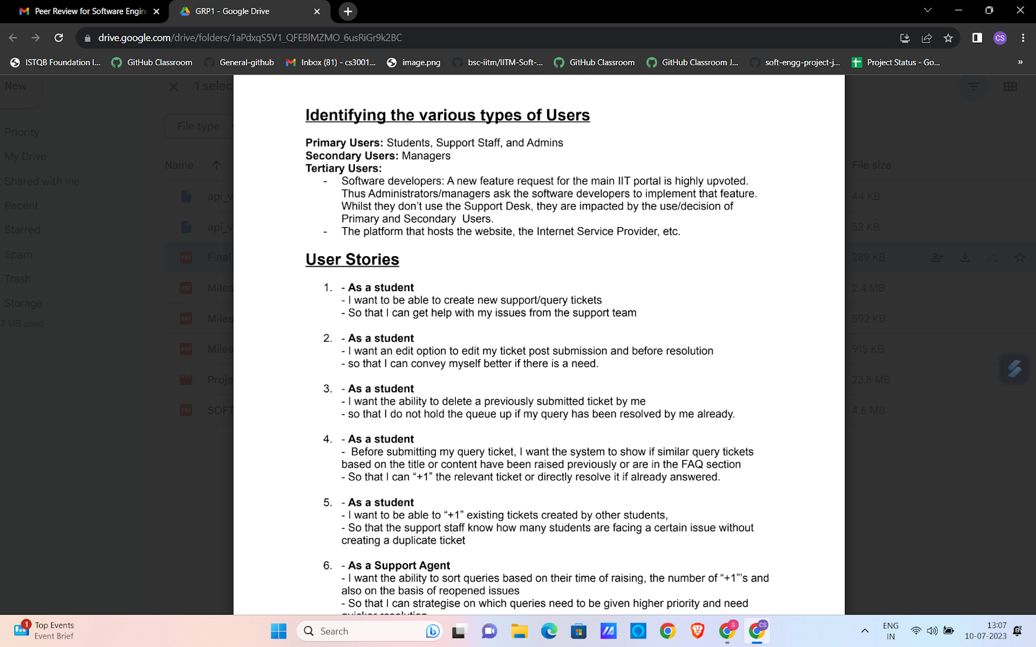
The following image is for illustration purposes.

MILESTONE 2
- Focus: Scheduling and Design
- Project Schedule - come up with a schedule of your overall project based on the user stories created in the previous milestones
- Create a schedule for your sprints and iterations, timings of your scrum meetings etc. Trello board, Gantt chart - specifying your tasks and contributions.
- Project Scheduling Tools - which tools are you using? E.g. Pivotal Tracker, Jira
- Design of Components - Describe different components of your system based on the user stories created in the previous milestones
- Software Design - Basic class diagrams of your proposed system
- Database Design - Design of your database
- Details/Minutes of a few scrum meetings
- Most of the pages in the UI (It may be modified (up to a certain limit) at a later time if necessary) - E.g.: HTML/CSS/Javascript (if you are using a framework like Vue.js or React.js, pages should be connected and redirection also implemented, have to submit the frontend folder without integration with backend API’s. Additionally provide a Readme file to run the frontend code).
- Milestone 2 PDF Report

Deliverables :
Milestone 2 PDF Report: Consolidated report including all the below components.
- Design of Components
- Class Diagram
- Databased Design diagram
- Sprint Schedule
- Scrum Meetings Schedule and Minutes
- Screenshot of Gantt Chart
- Screenshot of Kanban Board
- Screenshots of the Frontend pages have been developed.
- Zip the frontend code with a README containing installation & run instructions.

PEER EVALUATION QUESTIONS

7. Project Schedule (out of 7): Full Gantt diagram and description present - 7,Partially present - 4, Absent - 0
8. Use of project scheduling tools (out of 5): Present - 5, Partially present - 3, Absent - 0
9. Describe different components of your system (out of 8): Components are fully identified with description - 8, Partially present - 4, Absent - 0
10. Basic class diagrams of your proposed system (out of 10): All classes with appropriate relationship - 10, Most classes with appropriate relationship - 7, A few classes with appropriate relationship - 5, A few classes with relationship which are not appropriate - 3, Absent - 0
11. Details/Minutes of a few scrum meetings (out of 5): Fully present - 5, Partially present - 3, Absent - 0
12. UI pages (add screenshots) (out of 20): All important pages - 20, Most of the pages - 15, A few pages - 8, Absent - 0
13. Overall milestone 1-3 (out of 5): Very impressive - 5, Impressive - 3, Poor - 0

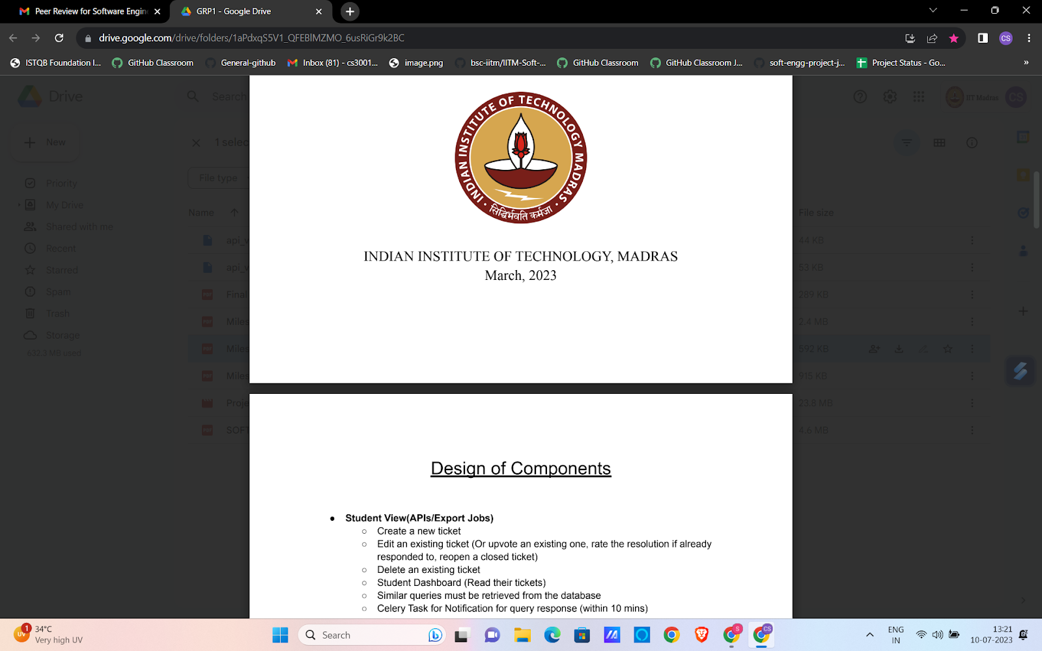
The following image is for illustration purposes.

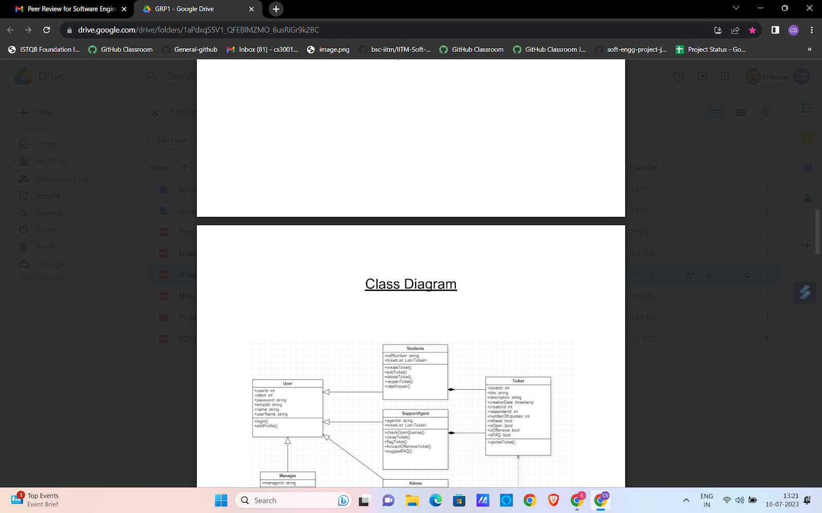
The following image is for illustration purposes.

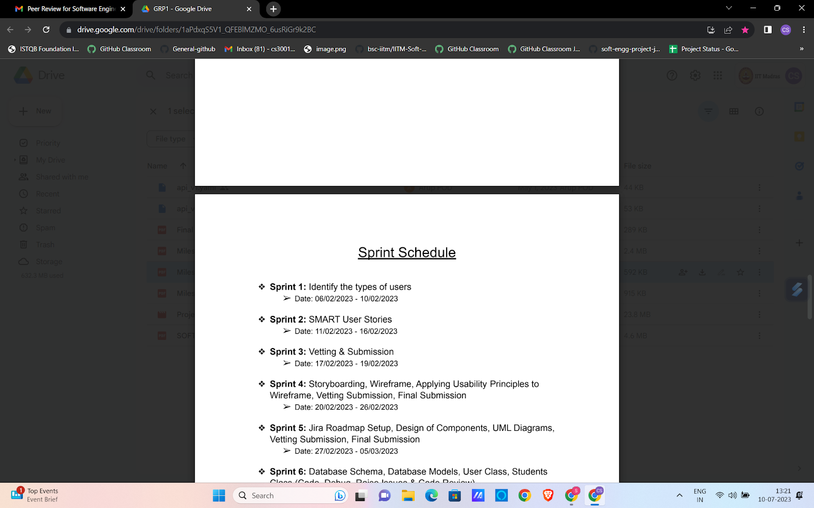
The following image is for illustration purposes.

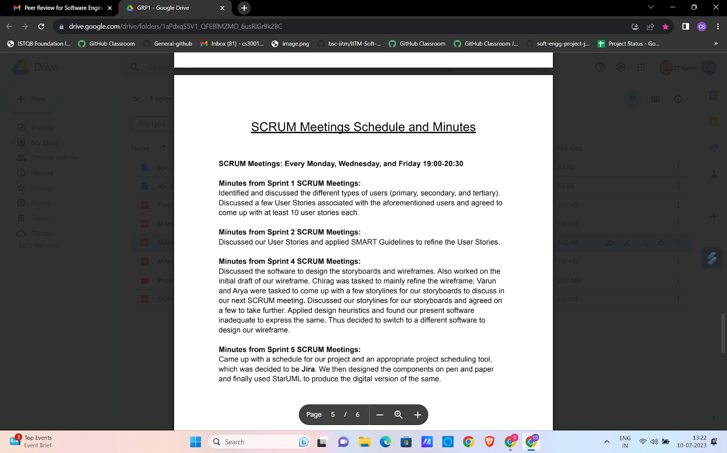
The following image is for illustration purposes.

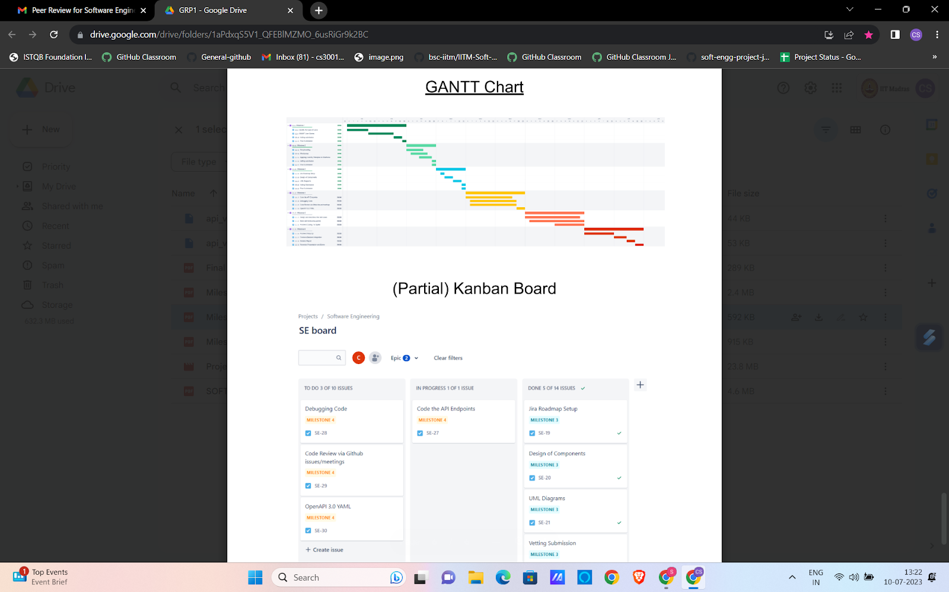
The following image is for illustration purposes.

SPRINT 1 and 2 (Separate Submissions for Each Sprint)
- Focus: API Endpoints, Test Cases, and User Testing
- For user story implementations decided for Sprint 1 or 2, create new API endpoints or use appropriate API endpoints from libraries
  - List of APIs integrated
  - List of APIs created
- Description of API endpoints. (As per the problem statement)
- Submission of YAML (for the APIs created by dev-team) (When submitting YAML file for API, make sure it is Swagger compatible)
- Code for the APIs (implementation)
- For each API endpoint, design extensive test cases. Test cases should be in the following format:
[ API being tested,
Inputs,
Expected output,
Actual Output,
Result- Success/Fail ]
- Show the features to the end users, get feedback and plan for next Sprint

Deliverables:
- Documentation of API’s in a Swagger-compatible YAML file.
- Backend code of the implemented API’s
Note: YAML file must have all the error handling, User stories mapping and description of each API listed.
- Proper test cases to test an API.
- For each test case, include the input, expected output, and actual output.
- You can also showcase any API where the actual and expected outputs differ. (This demonstrates how testing helps improve your API.)
- Submit pytest code for these APIs.
- User feedback and plan for next sprint

PEER EVALUATION QUESTIONS FOR SPRINT 1 and 2:

1. API Creation and integration (out of 15):
- Provide a detailed description of the APIs in the YAML file, ensuring all API's are clearly listed.
- Explain how the developed API’s are linked with the user stories, specifying how each API helps to implement the different user stories provided in Milestone 1. If APIs (such as GenAI APIs or any other open source software integration) have been integrated to create new ones, describe their usage in the next section.

YAML contains all of the required API’s and they are mapped to all the user stories. Additionally , any integrated APIs from GenAI (created by dev-team) are clearly listed - 15, YAML has some required APIs and some user stories are implemented, and integrated and GenAI Api’s listed- 8, YAML has some required API, but it is not formatted properly and the user stories not implemented, GenAI API’s not listed - 3, Absent - 0

2. Code for the APIs - Implementation (out of 20):
- Provide the complete code for the APIs that have been implemented.
- Ensure that the code is well commented and with proper error handling, validation and responses. The implementation should match the YAML and User stories.
Code for all APIs are present, well documented adheres the best practices (error handling, validation and responses), fully implements the user stories - 20, Code for all the APIs is according to YAML and user stories but best practices (error handling, validation and responses) not followed- 15, Code is incomplete, poorly formatted, lacks proper documentation, but according to User Stories - 10 Code is incomplete, poorly formatted, lacks proper documentation and failed to implement User Stories - 5, Absent - 0

3. Design and describe extensive test cases (out of 20):
- Test cases for APIs created.
- Test cases for other functionalities.

Most of the important test cases with proper format - 20, Some of the important test
cases with proper format - 15, Some of the important test cases (not formatted properly)- 10, Test cases are not correct - 5, Absent - 0

4. Some basic unit tests using pytest (out of 5):
pytest code/output present - 5, pytest code/output present, but error are not highlighted
- 3, Absent - 0

Sample screenshots based on the previous term’s problem statement:

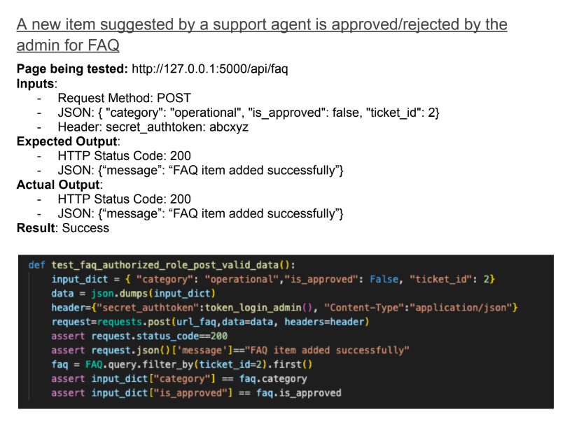
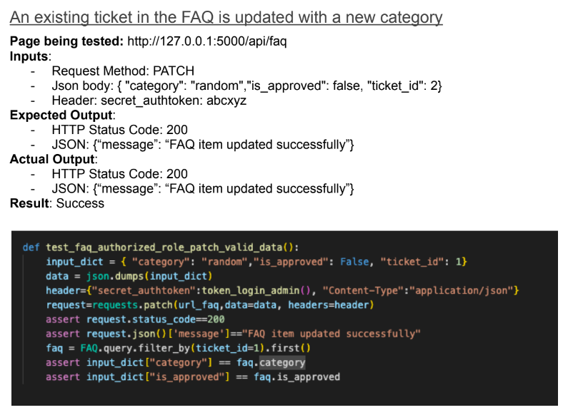

FINAL SUBMISSION

- Focus: Final Submission pdf
- Week-12 is completely focused on the project, and no new course content is released this week
- Complete implementation along with a working prototype.
- Final project report (consistent with intermediate milestone and sprint documents).
- Detailed report on work done across all milestones and sprints
- Implementation details of your project
  - 1. Technologies and tools used
  - 2. And instructions to run your application.
- A section describing code review, issue reporting and tracking using screenshots.
- Recorded presentation and presentation slides of the working model of your system.
Deliverables:
- Video presentation (anyone from the team can record a demo of the working of the Project.
- presentation (please include a brief overview of the whole project, mainly focusing on user stories and user identification)
- Complete code of the working Project in zip format.
- Readme file, which has all the instructions to run the project.
- The final pdf report, which has a complete compilation of all milestones and sprints .
  - Including tools and technologies used
  - Issue tracking that you have used during the project

PEER EVALUATION QUESTIONS:

5. Presentation and recorded demo of your application(out of 5):
Submitted - 5,
Not submitted - 0

6. Tool & Technology (Out of 15):
All tools and technologies are presented - 15,
Most of the tools and technologies are presented - 10,
Some of the tools and technologies are presented- 5,
Absent - 0

7. Issue tracker (Out of 10):
Issue trackers are present with regular updates- 10, Issue trackers are present with irregular updates - 5, Absent -0

8. Instructions to run your application (Out of 5):
Available in full details - 5, Some information available - 3, Absent - 0

9. Overall (out of 5): Very impressive - 5, Impressive - 3, Poor - 0

Implementation Details of the Project

● Technologies and tools used

○ Technologies for the backend
■ Flask
■ Flask Restful (For creating API endpoints)
…..

○ Technologies for the frontend
■ Vue 3 CLI
■ JavaScript
■ Vue Router
….

○ Technologies for GenAI integration
■ OpenAI API
■ Gemini API
■ HuggingFace API
■ LangChain
….

○ General technologies used
■ GitHub (for versioning, code management, tracking, reviewing,
issues, etc.)
■ Algolia Search is used in the backend and frontend to create a
smooth search experience
■ Jira (for project management)
….

● Hosting: info regarding hosting

● Instructions to run the application

○ On Ubuntu/MAC OS:
■ Git clone the repository.
■ Change the directory to the “backend” directory inside the
“Milestone-6-Final-Submission” directory using the command :
cd ./Milestone-6-Final-Submission/Code/backend
■ Create a Python virtual environment using the command:
python3 -m venv “<<Name of the virtual environment”>>
■ Activate the virtual environment using the command:
source <<Name of the virtual environment>>/bin/activate
■ Install the requirements using the command :
pip3 install -r requirements.txt…..and so on

○ On Windows:
■ Git clone the repository.
■ Change the directory to the “backend” directory inside the
“Milestone-6-Final-Submission” directory using the command :
cd .\Milestone-6-Final-Submission\Code\backend…and so on
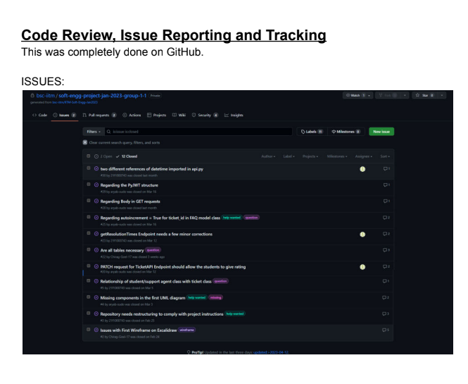
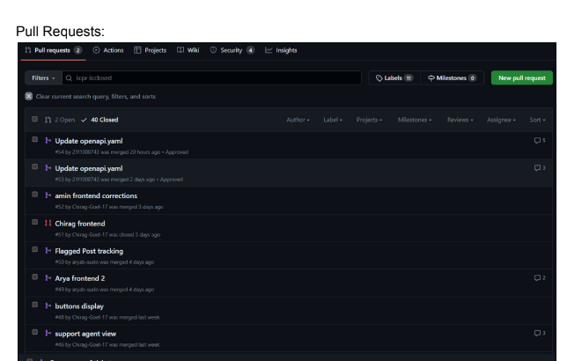

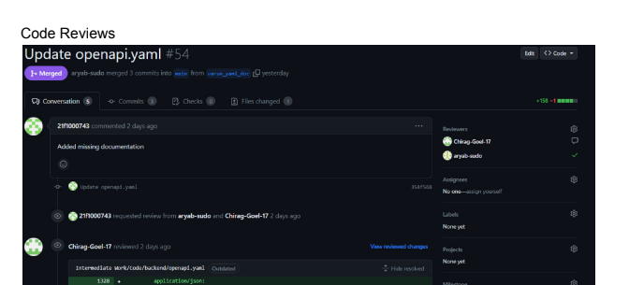

Project Presentation
- We will schedule a Software Engineering Project Showcase, where each group will present their project to instructors, other groups, and even other students in the BS program
- The presentation will be graded.
- Components evaluated in final Project Evaluation:
1. The overall design of the project.
2. Teamwork that includes code review, issue reporting and tracking etc.
3. Efficient coding practices.
4. Consistent design through different milestones

